Project Planning Phase

**Usage of JIRA Software**

|  |  |
| --- | --- |
| Date | 18 October 2022 |
| Team ID | PNT2022TMID52681 |
| Project Name | Inventory Management System for Retailers |
| Maximum Marks | 2 Marks |

1. Create a new JIRA Board using SCRUM Template.

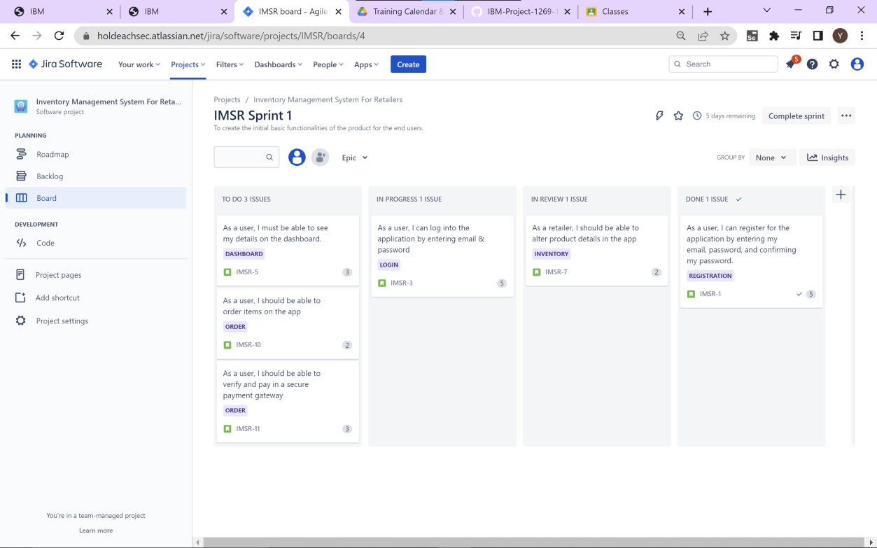

1. Add items to backlog and then transfer into Sprints.

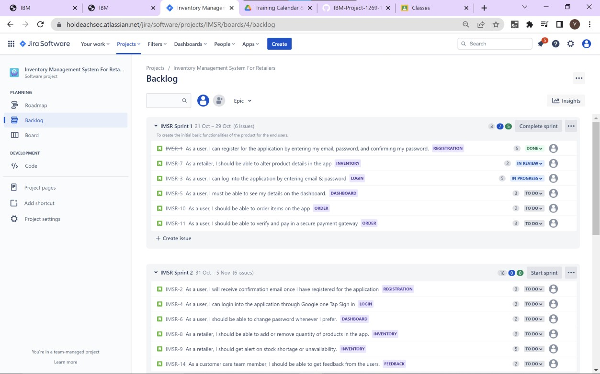

1. Assign story points to each process.

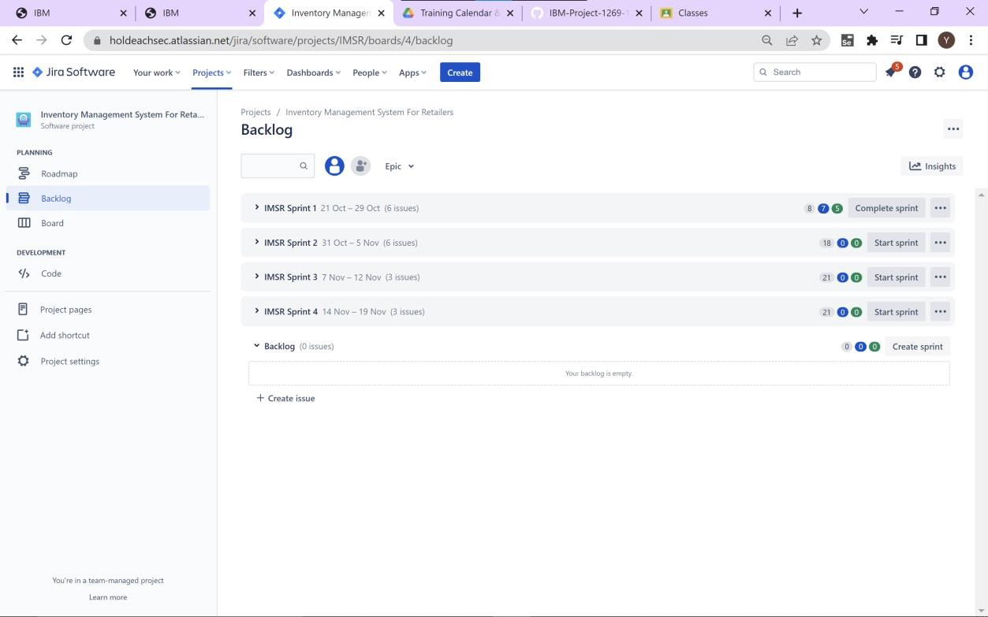

1. Assign each process to a epic.
2. Invite members to the JIRA board and assign each process to a member.
3. Start the Sprint-1 and then move cards in the scrum board when its finished.

Roadmap for the project:

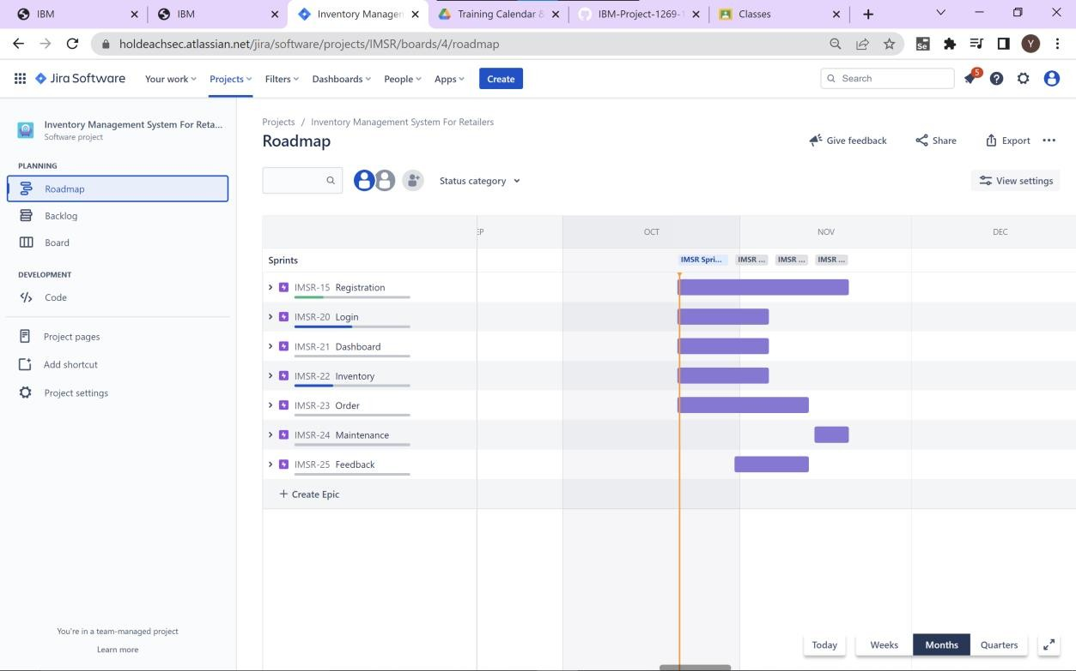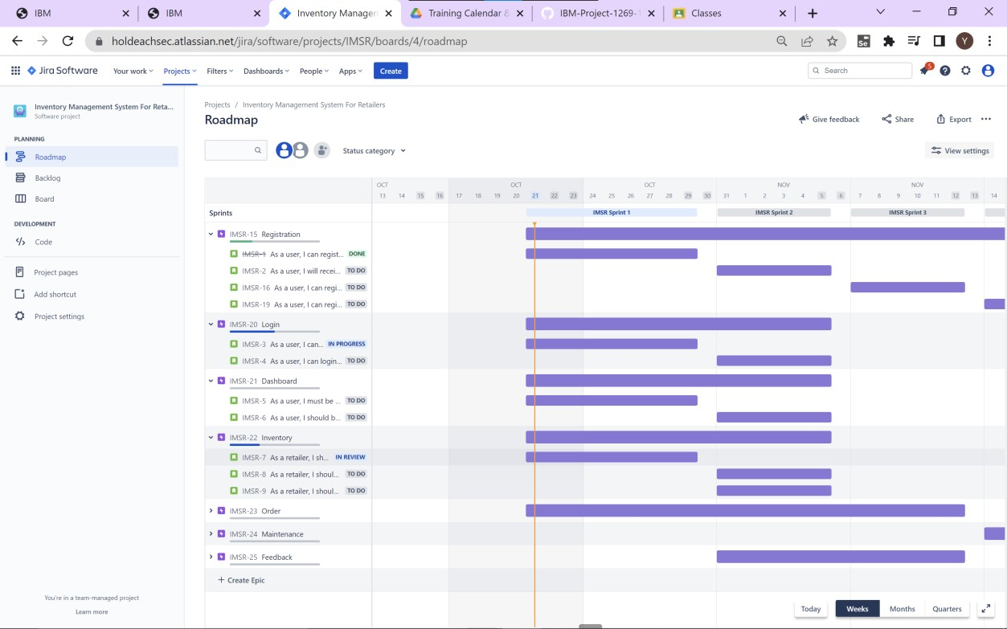

Thus in this way SCRUM framework in JIRA can be used for the management of our project.